**LAMPIRAN**

Lampiran 1. Gambar Bandar Udara Kalimarau melalui *Google Maps*

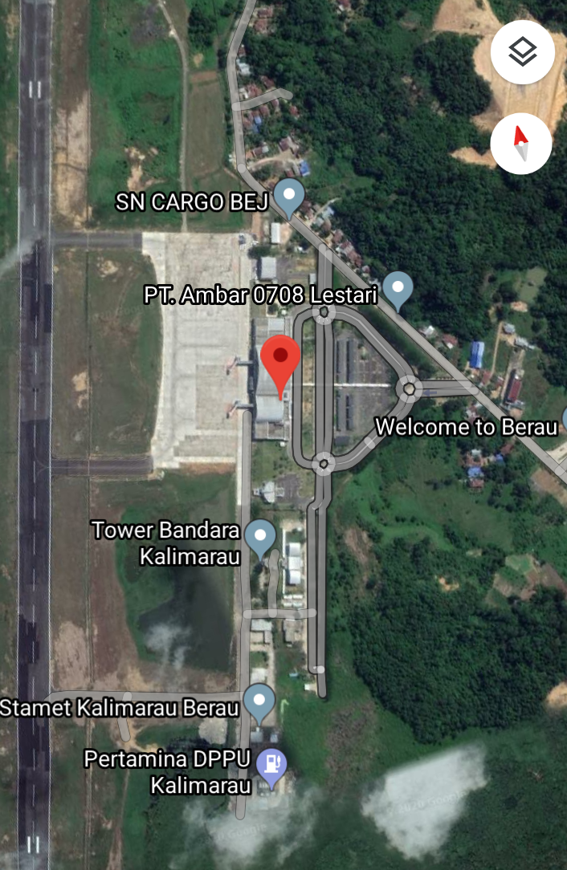

Lampiran 2. Perhitungan PERT Menggunakan *Q.M for Windows*

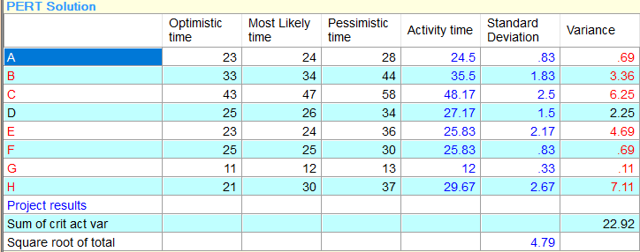

*Sumber: Q.M for Windows V5,2020*

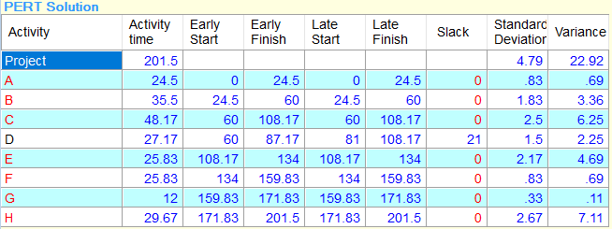

*Sumber: Q.M for Windows V5,2020*

Lampiran 3. Grafik PERT Menggunakan *Q,M for Windows*

*Precendence Graph*

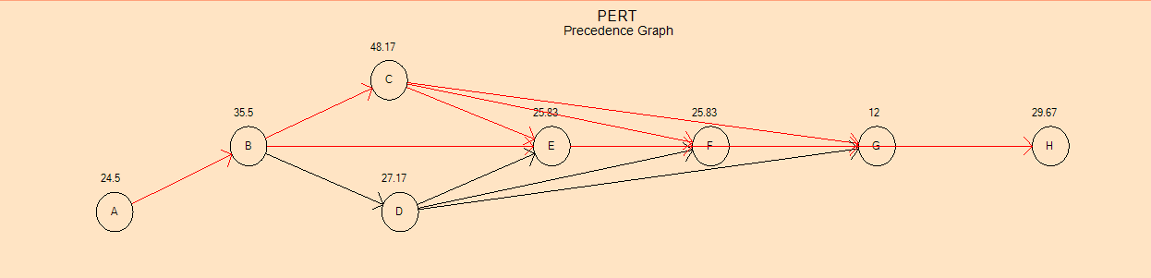

*Sumber: Q.M for Windows V5,2020*

*Gantt Chart (Early Times)*

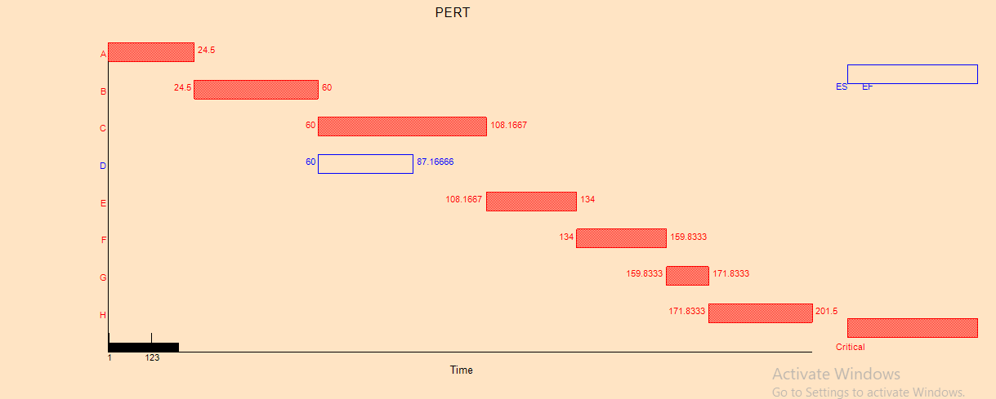

*Sumber: Q.M for Windows V5,2020*

*Gantt Chart (Late Times)*

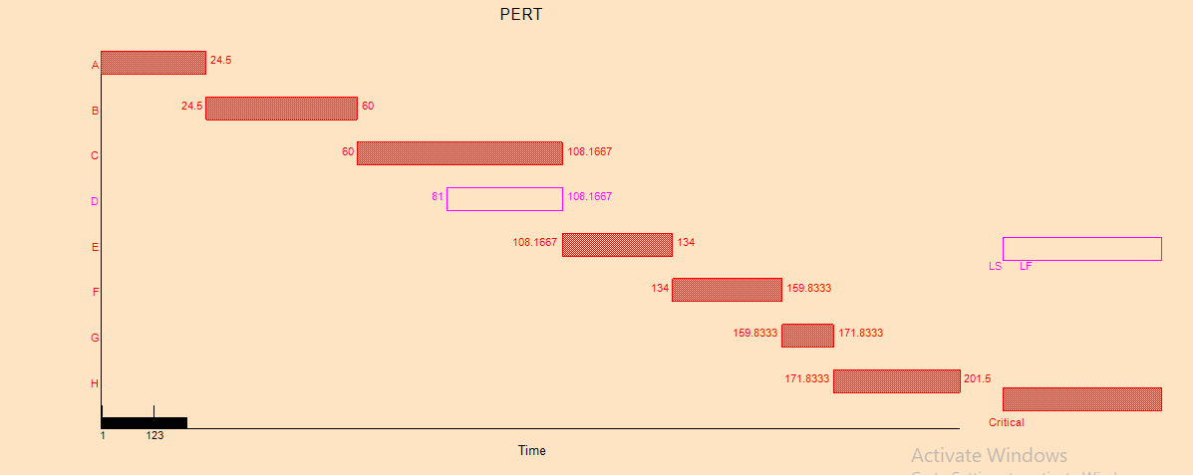

*Sumber: Q.M for Windows V5,2020*

*Chart (Early and Late Time)*

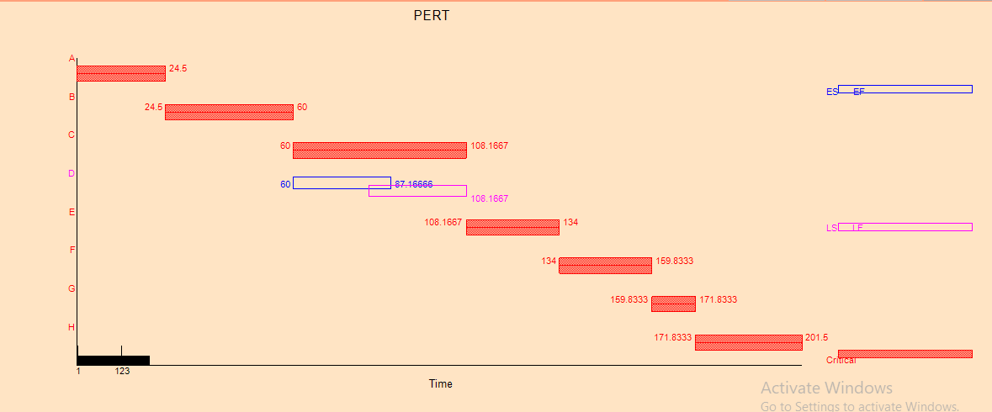

*Sumber: Q.M for Windows V5,2020*

Lampiran 4. Metode Crashing Menggunakan *Q.M for Windows*

*Project Management Crashing Result*

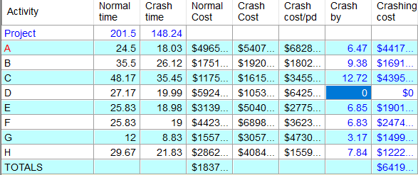

*Sumber: Q.M for Windows V5,2020*

*Detailed Schedule*

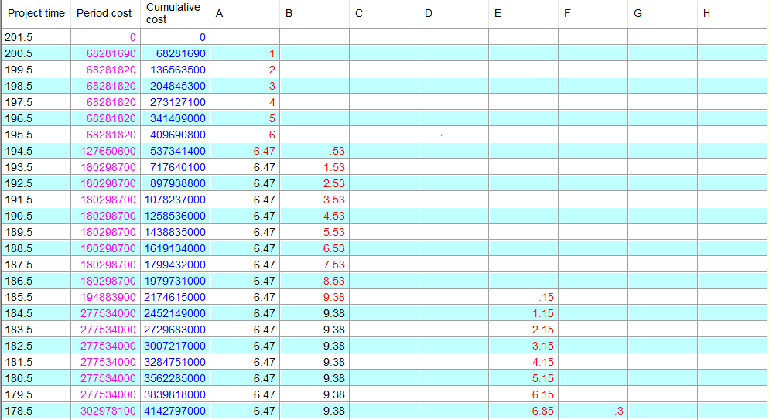

*Sumber: Q.M for Windows V5,2020*

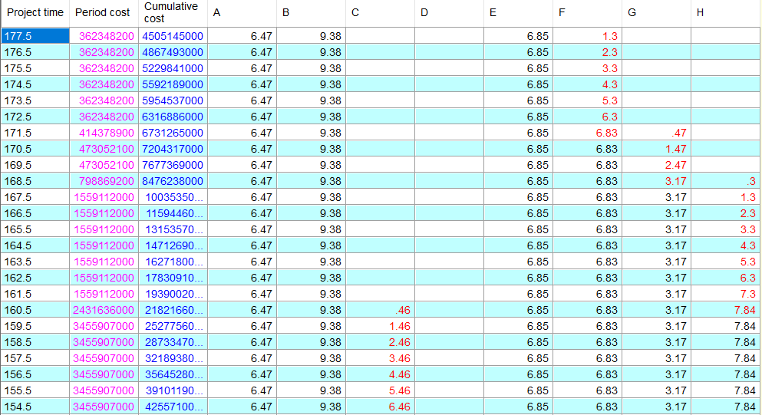

*Sumber: Q.M for Windows V5,2020*

*Crash Schedule*

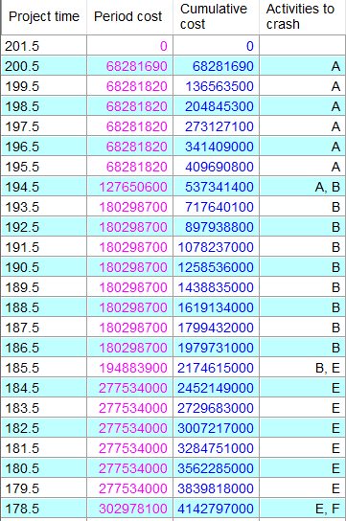

*Sumber: Q.M for Windows V5,2020*

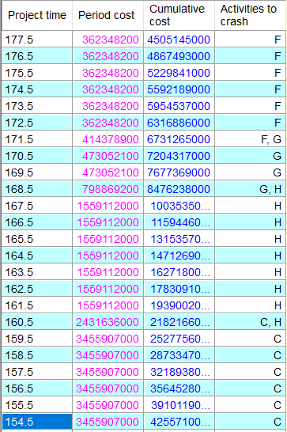 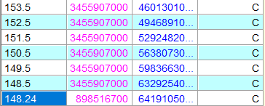

*Sumber: Q.M for Windows V5,2020*