|  |  |  |  |  |  |
| --- | --- | --- | --- | --- | --- |
| **Descriptive Statistics** | | | | | |
|  | N | Minimum | Maximum | Mean | Std. Deviation |
| KEPEMILIKAN MANAJERIAL | 70 | ,00 | ,68 | ,0988 | ,16505 |
| KOMISARIS INDEPENDEN | 70 | ,33 | ,67 | ,4089 | ,08202 |
| KOMITE AUDIT | 70 | 2,00 | 4,00 | 3,0286 | ,41603 |
| MANAJEMEN LABA | 70 | -,26 | ,18 | -,0704 | ,07332 |
| Valid N (listwise) | 70 |  |  |  |  |

|  |  |  |
| --- | --- | --- |
| **One-Sample Kolmogorov-Smirnov Test** | | |
|  | | Unstandardized Residual |
| N | | 70 |
| Normal Parametersa,b | Mean | ,0000000 |
| Std. Deviation | ,06640107 |
| Most Extreme Differences | Absolute | ,087 |
| Positive | ,087 |
| Negative | -,071 |
| Test Statistic | | ,087 |
| Asymp. Sig. (2-tailed) | | ,200c,d |
| a. Test distribution is Normal. | | |
| b. Calculated from data. | | |
| c. Lilliefors Significance Correction. | | |
| d. This is a lower bound of the true significance. | | |

|  |  |  |  |  |  |
| --- | --- | --- | --- | --- | --- |
| **Model Summaryb** | | | | | |
| Model | R | R Square | Adjusted R Square | Std. Error of the Estimate | Durbin-Watson |
| 1 | ,424a | ,180 | ,143 | ,06789 | 2,171 |
| a. Predictors: (Constant), KOMITE AUDIT, KEPEMILIKAN MANAJERIAL, KOMISARIS INDEPENDEN | | | | | |
| b. Dependent Variable: MANAJEMEN LABA | | | | | |

|  |  |  |  |  |  |  |  |  |  |
| --- | --- | --- | --- | --- | --- | --- | --- | --- | --- |
| **Coefficientsa** | | | | | | | | | |
| Model | | Unstandardized Coefficients | | Standardized Coefficients | t | Sig. | Collinearity Statistics | |
| B | Std. Error | Beta | Tolerance | VIF |
| 1 | (Constant) | -,092 | ,062 |  | -1,467 | ,147 |  |  |
| KEPEMILIKAN MANAJERIAL | -,085 | ,050 | -,192 | -1,700 | ,094 | ,974 | 1,027 |
| KOMISARIS INDEPENDEN | ,392 | ,111 | ,439 | 3,522 | ,001 | ,801 | 1,248 |
| KOMITE AUDIT | -,043 | ,022 | -,245 | -1,981 | ,052 | ,813 | 1,230 |
| a. Dependent Variable: MANAJEMEN LABA | | | | | | | | | |

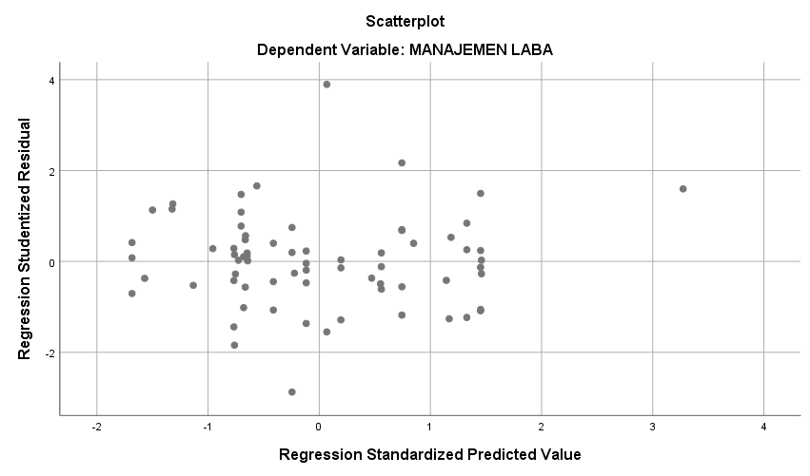

|  |  |  |  |  |  |  |  |
| --- | --- | --- | --- | --- | --- | --- | --- |
| **Coefficientsa** | | | | | | | |
| Model | | Unstandardized Coefficients | | Standardized Coefficients | t | Sig. |
| B | Std. Error | Beta |
| 1 | (Constant) | -,092 | ,062 |  | -1,467 | ,147 |
| KEPEMILIKAN MANAJERIAL | -,085 | ,050 | -,192 | -1,700 | ,094 |
| KOMISARIS INDEPENDEN | ,392 | ,111 | ,439 | 3,522 | ,001 |
| KOMITE AUDIT | -,043 | ,022 | -,245 | -1,981 | ,052 |
| a. Dependent Variable: MANAJEMEN LABA | | | | | | | |

|  |  |  |  |  |  |  |
| --- | --- | --- | --- | --- | --- | --- |
| **ANOVAa** | | | | | | |
| Model | | Sum of Squares | df | Mean Square | F | Sig. |
| 1 | Regression | ,067 | 3 | ,022 | 4,825 | ,004b |
| Residual | ,304 | 66 | ,005 |  |  |
| Total | ,371 | 69 |  |  |  |
| a. Dependent Variable: MANAJEMEN LABA | | | | | | |
| b. Predictors: (Constant), KOMITE AUDIT, KEPEMILIKAN MANAJERIAL, KOMISARIS INDEPENDEN | | | | | | |

|  |  |  |  |  |  |
| --- | --- | --- | --- | --- | --- |
| **Model Summaryb** | | | | | |
| Model | R | R Square | Adjusted R Square | Std. Error of the Estimate |
| 1 | ,424a | ,180 | ,143 | ,06789 |
| a. Predictors: (Constant), KOMITE AUDIT, KEPEMILIKAN MANAJERIAL, KOMISARIS INDEPENDEN | | | | | |
| b. Dependent Variable: MANAJEMEN LABA | | | | | |

|  |  |  |  |  |  |  |  |
| --- | --- | --- | --- | --- | --- | --- | --- |
| **Coefficientsa** | | | | | | | |
| Model | | Unstandardized Coefficients | | Standardized Coefficients | t | Sig. |
| B | Std. Error | Beta |
| 1 | (Constant) | -,092 | ,062 |  | -1,467 | ,147 |
| KEPEMILIKAN MANAJERIAL | -,085 | ,050 | -,192 | -1,700 | ,094 |
| KOMISARIS INDEPENDEN | ,392 | ,111 | ,439 | 3,522 | ,001 |
| KOMITE AUDIT | -,043 | ,022 | -,245 | -1,981 | ,052 |
| a. Dependent Variable: MANAJEMEN LABA | | | | | | | |